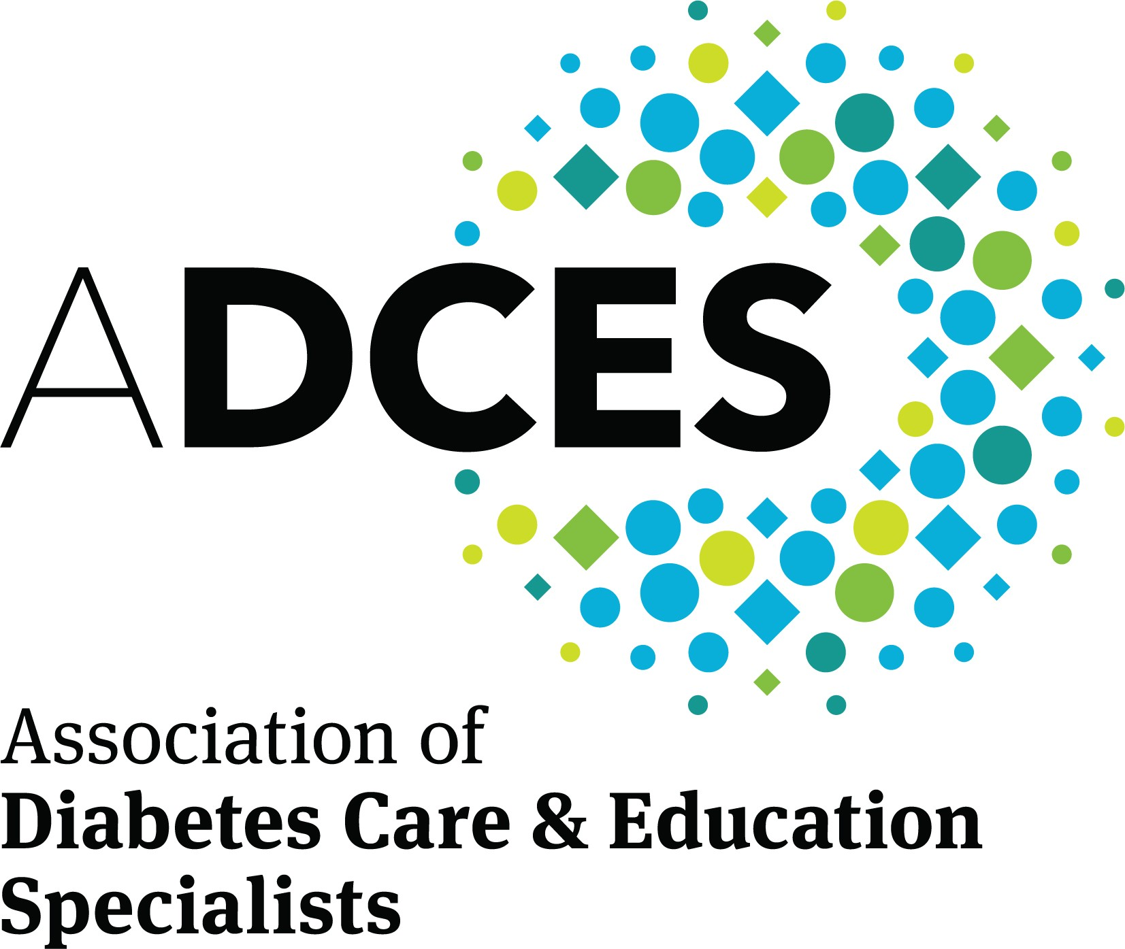
Send to: ADCES
Department 4445
Carol Stream, IL 60122-4445 800.338.3633, Select Option 3 Membership@adces.org diabeteseducator.org

Name

Address

City
State
Zip Code

Phone Email

Product Number | Product Description | Quantity | Price
 | Subtotal |  | $
 | Tax (Illinois Residents add 10.25%) |  | $
 | Shipping and Handling – see chart below |  | $
 | TOTAL |  | $

Shipping and Handling Fees (Orders outside the continental US should call 800.338.3633 x 100)

Merchandise Total | Shipping and Handling Fees | Merchandise Total | Shipping and Handling Fees | Merchandise Total | Shipping and Handling Fees
$0-$25 | $7.95 | $200.01-$250.00 | $30.00 | $700.01- $800.00 | $96.00
$25.01-$50.00 | $9.95 | $250.01-$300.00 | $36.00 | $800.01-$900.00 | $108.00
$50.01-$75.00 | $13.95 | $300.01-$400.00 | $48.00 | $900.01-1,000.00 | $120.00
$75.01-$100.00 | $15.95 | $400.01-$500.00 | $60.00 | $1000.01-$2000.00 | $240.00
$100.01-$150.00 | $17.95 | $500.01-$600.00 | $72.00 | $2,000.01-$3000.00 | $360.00
$150.01-$200.00 | $19.95 | $600.01-$700.00 | $84.00 | $3000.01-$4000.00 | $480.00

Payment

Check: Payment enclosed payable to ADCES

Credit Card: AMEX VISA MASTERCARD DISCOVER

Credit Card Number

Expiration Date Security Code (SVC)

Signature

