Career Path Certificate Program Instructions
1: After you select GO

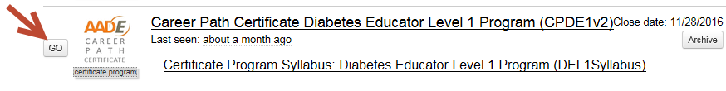
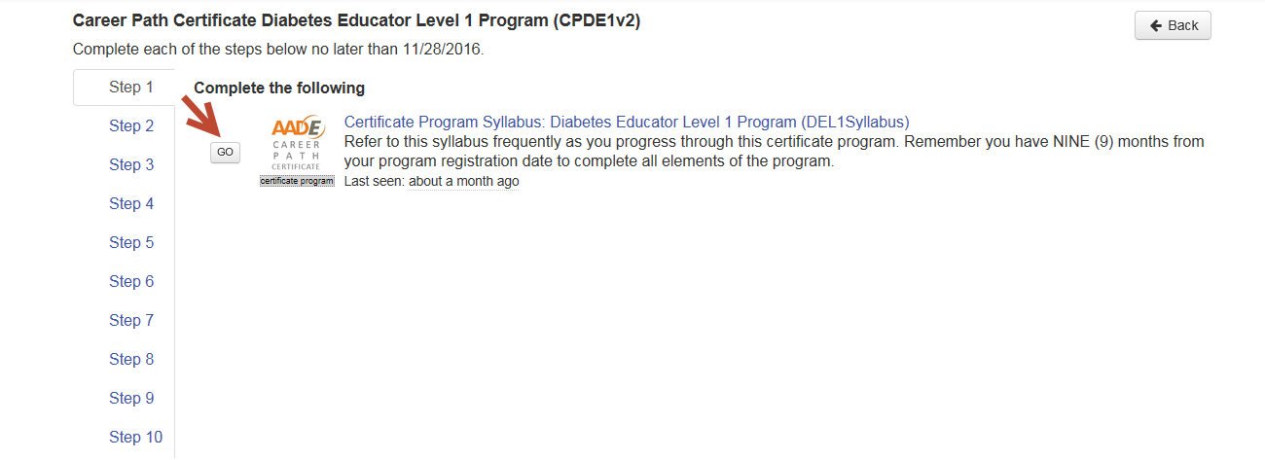
Please see example of this on page 4
2: you will need to read the Syllabus

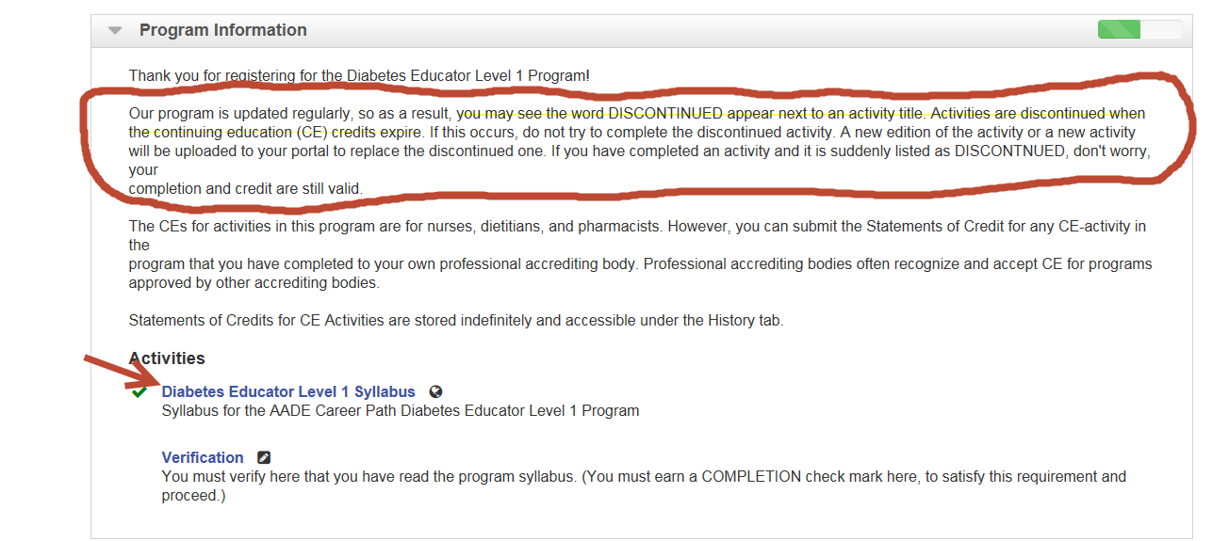
VERY IMPORTANT
3:
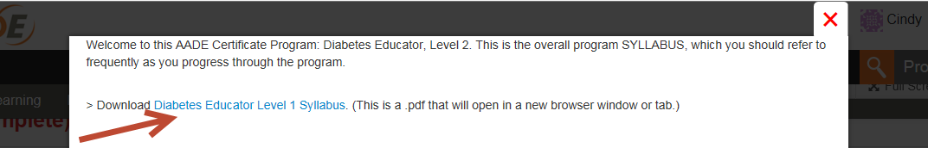
4: You may now print the syllabus

5: To go back to the Certificate program, select the open window

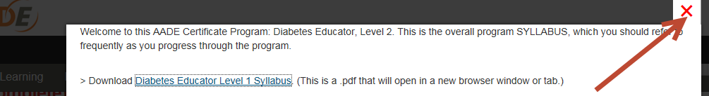
6: Select the RED X and close the box

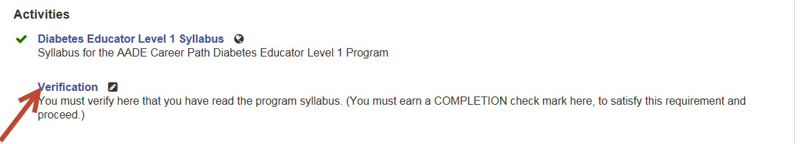
7: Select Verification

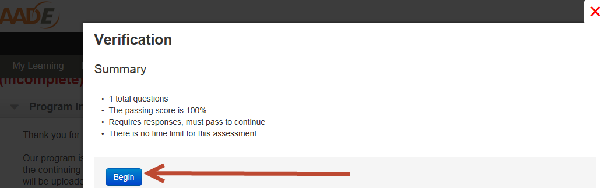
8: Select Begin

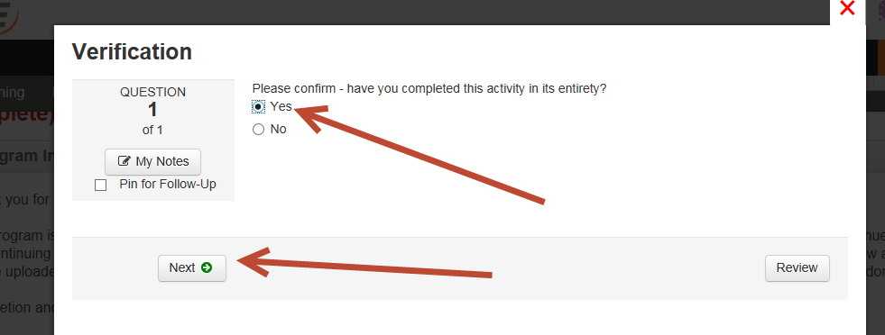
9: Select Yes

10: Then select next

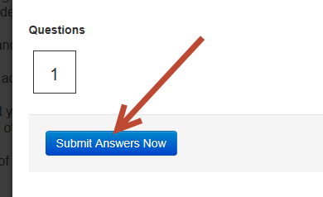
11:
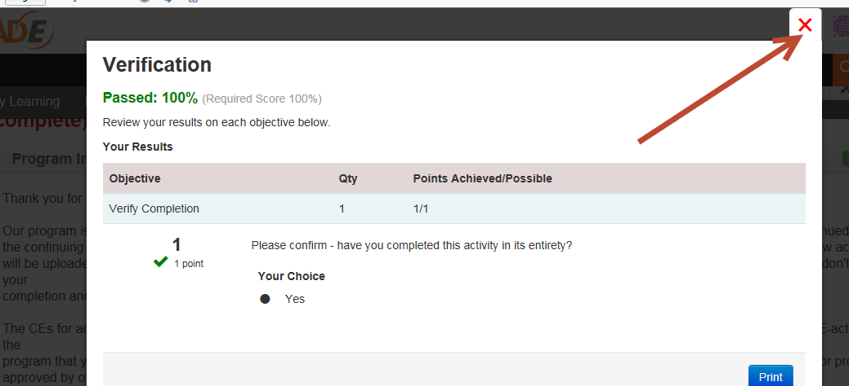
12: Select the RED X to close the window

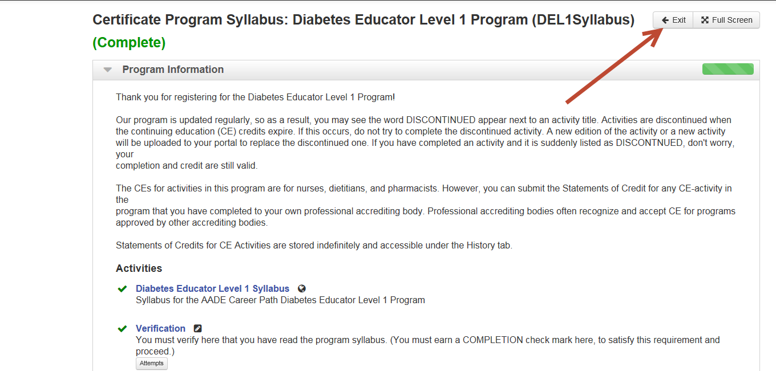
13: Select Exit
You have completed Step 1 so there is a green check mark, now you are in Step 2, please complete all the steps.
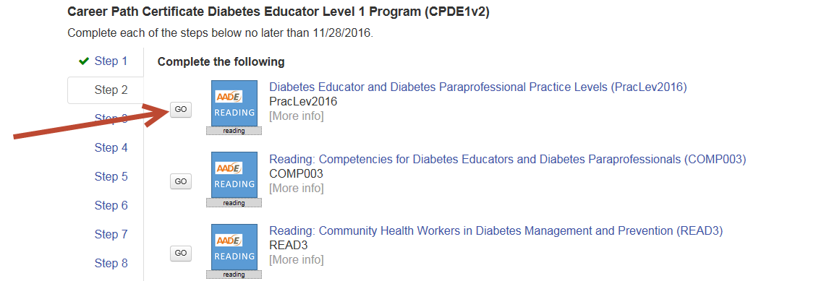
14:

Below is an example of discontinued programs you may encounter

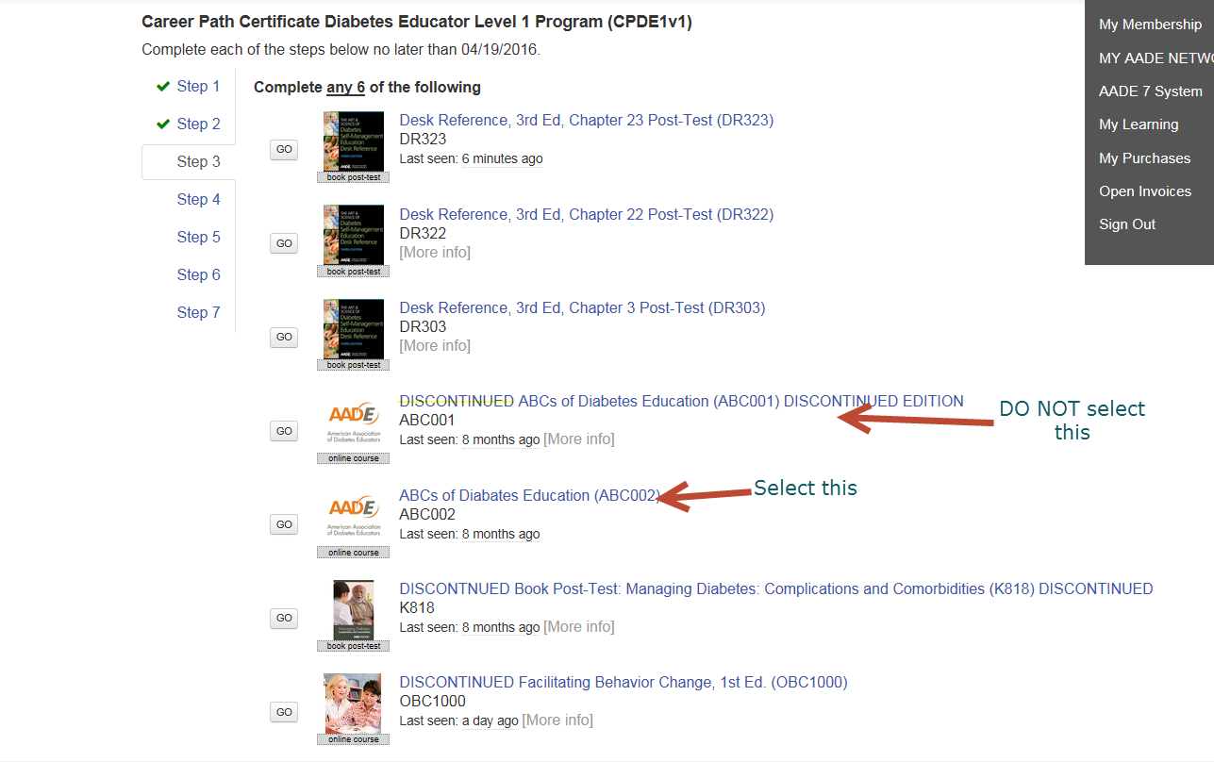
Note: It states you need to complete 6 however there are not 6 modules to complete. Two modules are discontinued and need to be replaced. In this instance, email education@aadenet.org and they will replace these two modules with new courses. You may go on to Step 4 at this point and go back to Step 3 once the new courses have been replaced

At the end of the program, a certificate will be mailed to you. The place card holder that states print certificate, does not actually print a certificate. Please email education@aadenet.org and advise them you have completed the career path program and would like your certificate mailed to you.

