Speaker Biographies and Financial Relationship Disclosures

In accordance with Joint Accreditation criteria and the ACCME’s Standards for Integrity and Independence in Accredited Continuing Education, the Association of Diabetes Care & Education Specialists (ADCES) must ensure that anyone in a position to control the content of the educational activity (planners and speakers/authors/discussants/moderators) has disclosed all relevant financial relationships with any [ineligible companies](https://accme.org/faq/what-accmes-definition-ineligible-company) for the past 24 months.

Joint Accreditation/ACCME also requires that ADCES mitigate any reported conflict and eliminate the potential for bias during the educational activity. The disclosure information is intended to identify any ineligible relationships and allow learners to form their own judgments. However, if you perceive a bias during the activity, please report it on the evaluation.

**All relevant financial relationships have been mitigated.**

Relevant disclosures (or lack thereof) among conference planners and faculty are as follows:

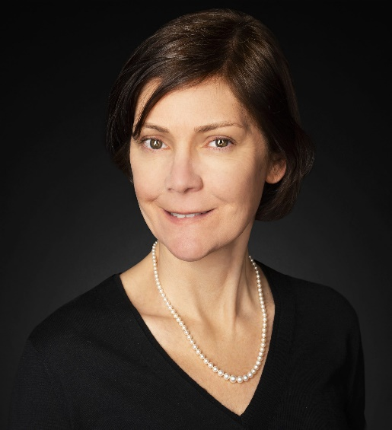 Natalie Bellini, APRN, FNP-BC, BC-ADM, CDCES

Endocrine Nurse Practitioner

R&B Medical Group

Natalie Bellini is an endocrine nurse practitioner at R&B Medical Group and member of the Catholic Health Inpatient Glycemic Management Team in Buffalo, NY. She is working with Diatribe and the International Time in Range Coalition to establish Time in Range as an essential part of diabetes care and ensure that Time in Range becomes the primary glucose metric for daily management, complemented by A1C, in diabetes care globally. She has spoken nationally and internationally to providers and patients about diabetes management and the use of technology in adults and teens. She is currently pursuing her doctorate in nursing practice.

***Disclosures****:*

* Abbott- Speaker’s Bureau

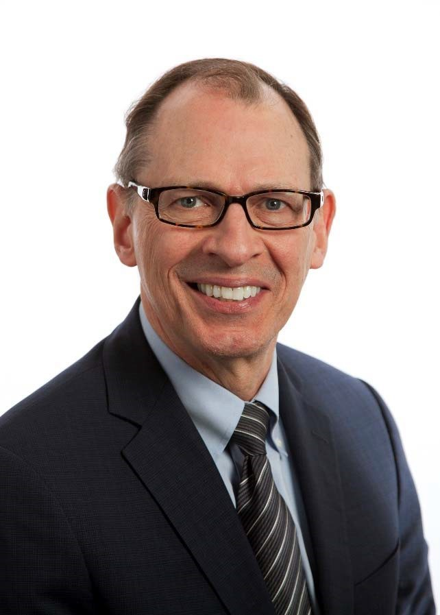

Richard Bergenstal, MD

Executer Director

International Diabetes Center

Richard M. Bergenstal, MD, is an endocrinologist and Executive Director of the International Diabetes Center at Park Nicollet. He is Clinical Professor in the Department of Medicine at the University of Minnesota and served as President, Science & Medicine of the American Diabetes Association in 2010.

His clinical research has focused on glucose management and diabetes complications and advanced technology including CGM and automated insulin delivery systems. He has served as a Principal Investigator of five NIH trials: DCCT, ACCORD, GRADE and two technology focused NIH grants, an insulin dose advisor system and a study of next generation automated insulin delivery systems.

***Disclosures:***

Abbott Diabetes Care- Consultant/Clinical Investigator

Ascencia- Consultant

Bigfoot Biomedical Inc.-Consultant

CeQur- Consultant

Dexcom- Consultant/Clinical Investigator

Eli Lilly- Consultant/Clinical Investigator

Hygieia-Consultant

Insulet- Clinical Investigator

Medtronic- Consultant/Clinical Investigator

Novo Nordisk- Consultant/Clinical Investigator

Onduo-Consultant

Roche- Clinical Investigator

Sanofi- Consultant/Clinical Investigator

United Health Care- Consultant

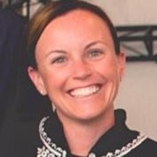

Jen Block, FNP, NP-C, MSN, BSRN, CDCES

Medical Affairs and Research

Apple Health

Bio



Mila Clarke Buckley

Editor In Chief and Founder

HangryWoman.com

Mila Clarke Buckley is an author, self-taught cook, diabetes advocate and founder of HangryWoman.com

Hangry Woman aims to take away the shame and stigma that comes with a diabetes diagnosis and covers topics like diabetes management, cooking, and self-care from the perspective of someone living with the chronic condition.

Mila has been featured by CNN, The New York Times, USA Today, Good Housekeeping and WebMD. She's a contributor to Healthline, DiabetesMine and EatingWell Magazine. She lives in Houston, Texas with her husband and two pups.

***Disclosures:***

* Abbott Diabetes Care, Freestyle Libre- Patient Ambassador

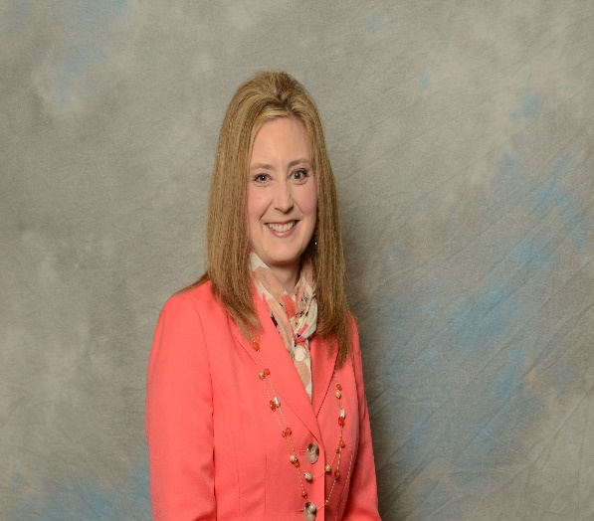Kathleen Eubanks-Meng, DO

ABFM Board Certified Family Physician

Summit Family and Sports Medicine

Dr. Eubanks-Meng is a family physician in a physician owned multi-specialty, multi-site primary care practice in the Greater Kansas City, Missouri Metropolitan area. Her practice is one of the first primary care clinics in Kansas City to be certified in caring for persons with diabetes. Dr. Eubanks-Meng is a past president and board chair for the Missouri Academy of Family Physicians (MAFP) and served as an MAFP board member representing the Kansas City area for over 10 years.

During Dr. Eubanks-Meng’s eighteen-year career providing primary care to persons with diabetes, her practice has incorporated a diabetes care and education specialist into their practice to offer more comprehensive care. Dr. Eubanks-Meng presented at the ADCES 2019 on the incorporation of professional CGM in primary care. She also recently discussed care teams and physician burn out during Covid-19 on an ADCES podcast.

***Disclosures:*** No financial relationships to report

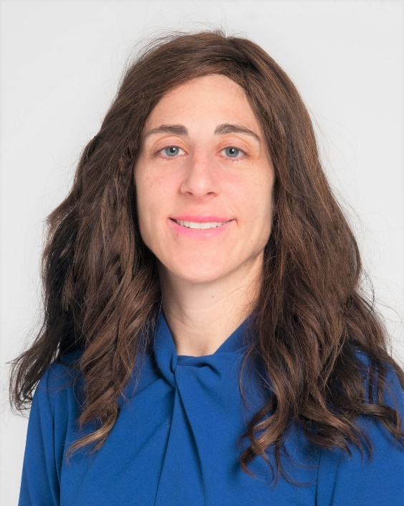

Diana Issacs, PharmD, BCPS, BC-ADM, CDCES

Endocrine Clinical Pharmacy Specialist

Cleveland Clinic Diabetes Center

Diana Isaacs, PharmD, BCPS, BC-ADM, BCACP, CDCES, FADCES, FCCP is the Remote Monitoring and CGM Program Coordinator and Endocrinology Clinical Pharmacy Specialist at the Cleveland Clinic Diabetes Center. Dr. Isaacs earned her Bachelor’s Degree in Chemistry from the University of Illinois at Chicago, Doctor of Pharmacy Degree from Southern Illinois University Edwardsville and completed residency at the Philadelphia VA Medical Center. Dr. Isaacs holds board certifications in pharmacotherapy, ambulatory care, and advanced diabetes management. In 2020, she was awarded Fellow status in the Association of Diabetes Care and Education Specialists (ADCES) and American College of Clinical Pharmacy (ACCP). She is the Communications Director for the American Diabetes Association (ADA) Pregnancy and Reproductive Health Interest Group and serves on the 2020-2021 ADA Professional Practice Committee, the committee that updates the ADA Standards of Care. She is also the president of the Ohio Association of Diabetes Care and Education Specialists (ADCES). She presents on diabetes related topics nationally and internationally. Dr. Isaacs was awarded the Ohio Pharmacists Association Under 40 Award in 2019 and ADCES Diabetes Care and Education Specialist of the Year in 2020.

***Disclosures:***

* Dexcom, Insulet, Medtronic, Abbott, Novo Nordisk, Bayer, Xeris Pharmaceuticals- Speakers Bureau
* Lilly, Sanofi, Tempramed, DiabetesWise, DiaTribe- Consultant

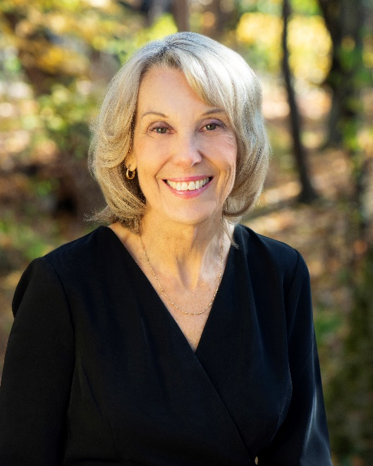 Monica Joyce, MS, RDN, LDN, CDCES

Clinical Dietitian

Northwestern Medicine

Monica Joyce, MS, RDN, CDCES is a clinical dietitian and a certified diabetes care and education specialist with over thirty years of clinical experience in both an endocrinology practice in Chicago, Illinois and currently at Northwestern Medicine in Lake Forest, Illinois. She also has been an adjunct Professor teaching nutrition in a Culinary Institute in Chicago, Ill.

Monica is the Founder and Executive Director of Slam Dunk for Diabetes, nonprofit organization that provides an opportunity for low income children to learn to manage their diabetes in a fun environment. She has won numerous awards and recognition for this program

She is a partner in Culinary Medics, LLC with endocrinologist Disha Narang, M.D.

***Disclosures:***

* Novo Nordisk- Speakers Bureau

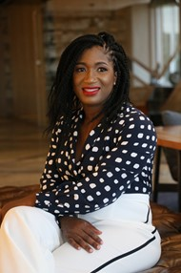

Vivian Nnacho Ayuk, PharmD, CDCES

CEO

Sorogi Inc.

Dr. Vivian Ayuk is a clinical pharmacist and Certified Diabetes Care and Education Specialist. She is an Alumna of the University Of Minnesota College Of Pharmacy with over 14 years of practice experience. She is also a serial entrepreneur and the CEO of Sorogi Inc.

She created and continues to operate the only nationally accredited Diabetes Self-Management Education and Support pharmacy-based program in the District of Columbia. This program is also a CDC recognized provider of the National Diabetes Prevention Program. She has led multiple successful pilot studies incorporating remote monitoring in personalizing care for patients with diabetes. She continues to work with a multidisciplinary team of professionals along with healthcare organizations to provide continuing education to allied health professionals and implement community health initiatives that addresses barriers to care

***Disclosures:*** No financial relationships to report

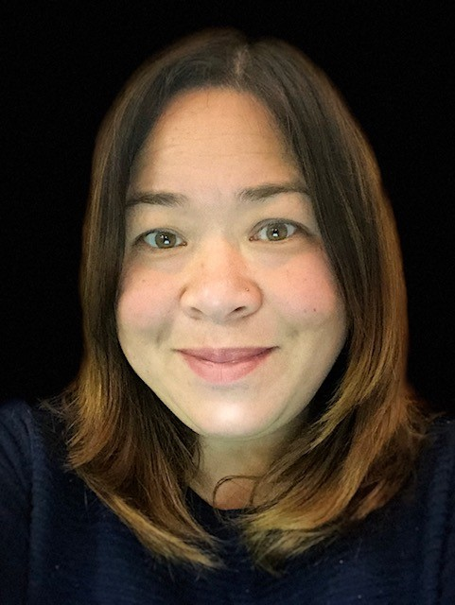

Anna Norton, MS

CEO

DiabetesSisters

Anna Norton, MS, the CEO of DiabetesSisters, is dedicated to improving the lives of women living with diabetes through peer support and education, via online and in-person programming. With over half a million annual visitors to [www.diabetessisters.org](https://nam02.safelinks.protection.outlook.com/?url=http%3A%2F%2Fwww.diabetessisters.org%2F&data=04%7C01%7Cjjohnson%40adces.org%7C784c228923424472374a08d96bb71a93%7Ca2d231343686485c8aa566290c3311ea%7C0%7C0%7C637659256454508690%7CUnknown%7CTWFpbGZsb3d8eyJWIjoiMC4wLjAwMDAiLCJQIjoiV2luMzIiLCJBTiI6Ik1haWwiLCJXVCI6Mn0%3D%7C1000&sdata=4fCqPrHWPZOpdyyOup4YbB47k2eNaJMeYqiaZBqwc44%3D&reserved=0), Anna organizes an array of programs including personal blogs, expert articles, and a well-read monthly newsletter.  In-person, she oversees a national peer support program for women living with all kinds of diabetes, a Leadership Institute to train patient advocates, a Conference series, and a bilingual Minority Initiative Program designed to educate underserved populations on diabetes and culture. She has been invited to serve on various patient-focused panels and speak on behalf of women living with diabetes at the American Diabetes Association Scientific Sessions, the Diabetes Care and Education Specialist Annual Meetings, and the International Diabetes Federation Congress in Abu Dhabi. She has been featured in an assortment of health-related magazines and books, including *Balancing Pregnancy with Pre-Existing Diabetes*, *A Woman’s Guide to Diabetes: A Path to Wellness. and Diabetic Living*.

***Disclosures:*** No financial relationships to report

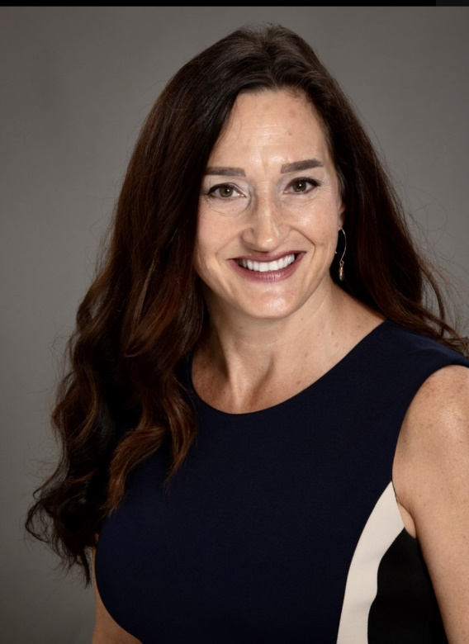

Jennifer Okemah, MS, RDN, BC-ADM, CDCES, CSSD

Owner and Diabetes Care & Education Specialist in Private Practice

Salute Nutrition, PLLC

Jennifer has been a Registered Dietitian/Nutritionist since 2005 and a Certified Diabetes Care and Education Specialist (CDCES) since 2007. She has an additional certification as a Sports Specialist in Dietetics as well as being Board Certified in Advanced Diabetes Management. Her unique niche is fluid knowledge on all technology products approved for diabetes care by the FDA. She loves data! She has been a leader in her field in patient care, mentoring, serving as a preceptor, speaking, creating webinars, writing for nutrition and diabetes blogs as well as authoring scientific publications. But what she loves most is taking confusing, complex information and helping people make it usable for them to reach the health goals they set for themselves. When she is not in a clinic or office, she can be found on her bicycle training for a JDRF fundraising ride, paddleboarding on Lake Washington (year around), hiking, traveling the world or just reading a book with a nice glass of wine.

***Disclosures:***

* Bigfoot Biomedical-Speakers bureau
* Medtronic, Tandem, Insulet, Dexcom, Mannkind- Consultant

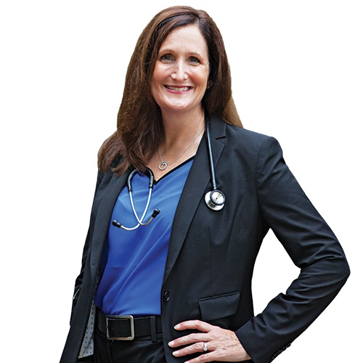

Anastasia Albanese-O'Neill, PhD, APRN, RN, CDCES

Clinical Assistant Professor and Director of Diabetes Education

Healthcare Consultant, Private Practice

Anastasia Albanese-O’Neill, PhD, APRN, CDCES, has been actively involved in diabetes care, education, and research since 2008, and has dedicated her career to improving the lives of people with diabetes. She is currently in private practice, where she serves as a key opinion leader on national committees and working groups, is an advisor to companies and non-profit organizations, and trains people with diabetes to use automated insulin delivery systems. Until 2021, Albanese-O’Neill was a faculty member and director of diabetes education and clinic operations in Pediatrics at the College of Medicine at the University of Florida, where she maintained an active research portfolio and clinical practice. Albanese-O'Neill's peer-reviewed research on diabetes education, quality improvement, and diabetes technology has been published in journals including *Diabetes Care, The Lancet,*and*Diabetes Technology & Therapeutics.* She plans to retire as soon as a cure is found for type 1 diabetes, but not a moment earlier.

***Disclosures:***

* Provention Bio- Consultant
* Tandem Diabetes, Medtronic, Insulet- Certified Product Trainer

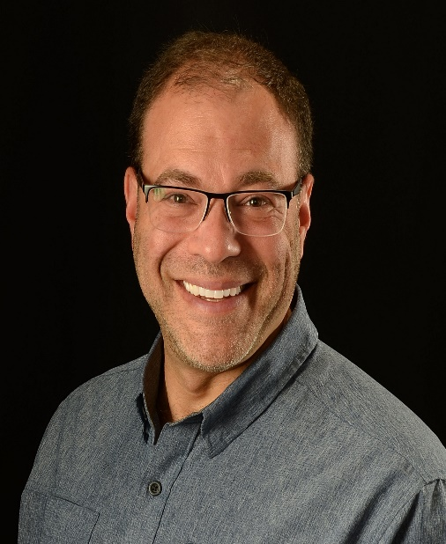

Sean Oser, MD, MPH

Associate Professor in the Department of Family Medicine

University of Colorado School of Medicine

Sean M. Oser, MD, MPH, has been living with type 1 diabetes since 1989 and is Associate Professor in the Department of Family Medicine at the University of Colorado School of Medicine, Associate Director of the Primary Care Diabetes Lab, and Medical Director of UCHealth Lone Tree Primary Care. Before relocating to Colorado, he was Associate Professor of Family and Community Medicine at Penn State College of Medicine and Associate Chief Medical Officer for Penn State Health’s Academic Practice Division. He places a strong emphasis on providing patient-centered, evidence-based, team-based, comprehensive care. He is a proponent of harnessing human, community, and technology resources in providing high quality longitudinal care and enhanced communication with patients. Dr. Oser is active in diabetes research, especially focusing on use of advanced diabetes technologies in primary care, including automated insulin delivery and continuous glucose monitoring, as well as practice innovation and practice transformation in incorporating new workflows and new therapies into primary care practices.

***Disclosures:***

* Cecelia Health and Dexcom- Consultant

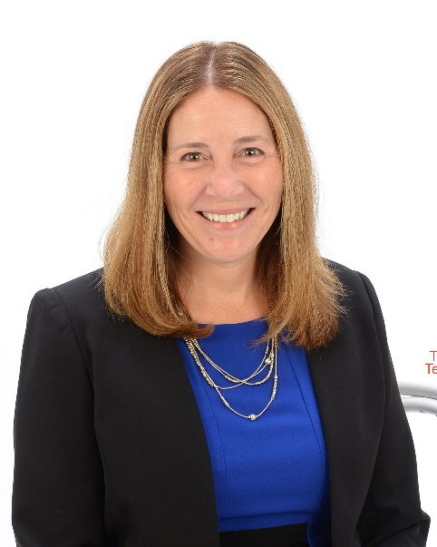

Tamara Oser, MD, MPH

Associate Professor of Family Medicine

University of Colorado School of Medicine

Dr. Tamara Oser is a board-certified family physician, Associate Professor of Family Medicine at the University of Colorado School of Medicine, Director of the Primary Care Diabetes Lab, and Director of the High Plains Research Network. She transitioned her career in academic medicine to focus on conducting research to improve the lives of people with diabetes when her daughter, Jessica, was diagnosed with type 1 diabetes shortly after she turned seven. Her research focuses on integrating diabetes technologies into primary care, the value of peer support in managing diabetes, and developing interventions to decrease disparities in the treatment of diabetes. In addition to maintaining an active family medicine practice, she is principal and co-investigator on a number of ongoing diabetes technology studies including both hybrid closed-loop insulin delivery and continuous glucose monitoring technology. She serves as an ADCES Media Spokesperson, on the Youth Strategies National Committee of the American Diabetes Association, and treasurer of the Behavioral Research in Diabetes Group Exchange (BRIDGE). As a practicing family physician, she has extensive clinical expertise in many practice settings and currently practices in a rural Federally Qualified Health Center with a large Hispanic/Latino population. Dr. Oser attended medical school at the University of Pittsburgh and completed a Family Medicine Residency at UPMC Shadyside, Pittsburgh.

***Disclosures:***

* Cecilia Health Diabetes and Dexcom-Consultant

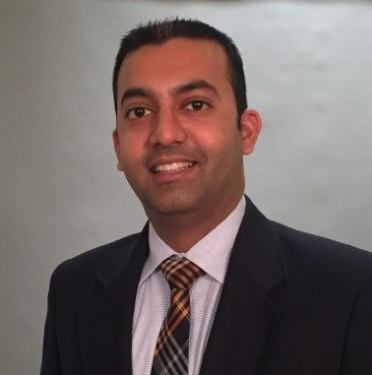

Dhiren Patel, PharmD, CDECS, BC-ADM

Adjunct Associate Professor of Pharmacy Practice

Massachusetts College of Pharmacy

Dr. Patel is an adjunct associate professor of pharmacy practice in the School of Pharmacy at Massachusetts College of Pharmacy in Boston, MA. He maintained a clinical practice site at the VA Boston Healthcare System for 12 years where he functioned as an endocrine clinical pharmacy specialist in the Endocrine Department. He has recently transitioned to a Cardiometabolic Concierge Clinic. Dr. Patel currently serves on the ADCES Technology Committee, American Diabetes Association’s Overcoming Therapeutic Inertia Initiative, CDC Diabetes Prevention Serious Game Steering Committee as well as a featured diabetes technology expert for the American Medical Association. Dr. Patel has also been published in numerous peer-reviewed journals and delivered numerous presentations and lectures on diabetes and diabetes technology.

***Disclosures:***

* Abbott, Amarin, Astra Zeneca, Bayer, Boehringer Ingelheim, Dexcom, Lilly, Merck, Novo, Xeris, Zealand-Speaker’s Bureau
* Amarin, Bayer, Dexcom, Lilly, Insulet- Consultant

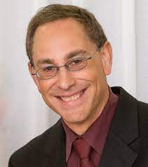Anthony Pick, MD, CDCES

Director of Endocrinology

Northwestern Medicine

Dr. Pick is Director of Endocrinology at Northwestern Medicine, Lake Forest Hospital, Assistant Professor of Endocrinology at Northwestern University, Feinberg School of Medicine. He is passionate about making an impact on cardiometabolic and endocrine disease with quality improvement initiatives, and the implementation of a team-based continuous care model of care, utilizing digital innovation and advanced decision-support, to work smarter, resulting in a greater impact and improved outcomes for a larger population of individuals. Other passions include Toby the empathetic labradoodle, his family and tennis.

***Disclosures:***

* Abbott, Astra Zeneca, Novo Nordisk, Lilly- Speakers Bureau

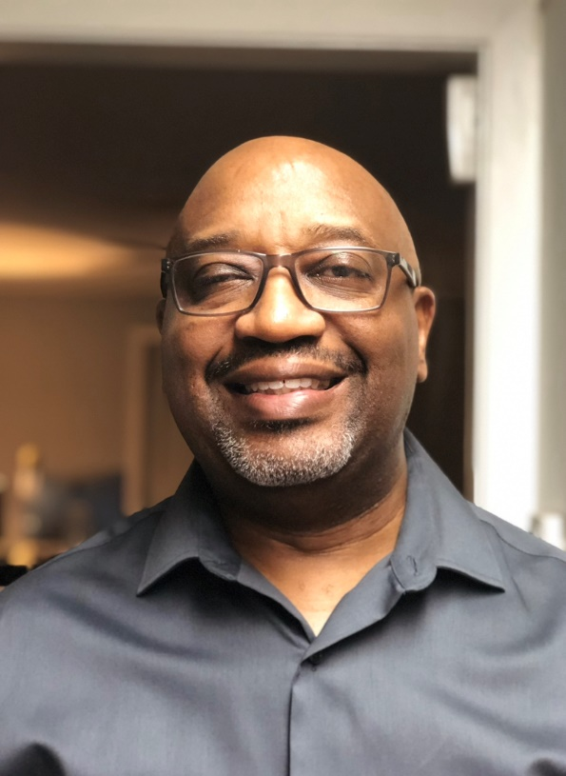

Chelcie Rice

T1International Communities of Color Lead

T1International Communities of Color Lead, comedian, speaker & Type 1 Diabetes advocate In spite of diabetic retinopathy. Currently host of The Soul of Diabetes Podcast. A podcast aimed at BIPOC communities and other marginalized communities affected by diabetes and their caregivers

***Disclosures:*** No financial relationships to report

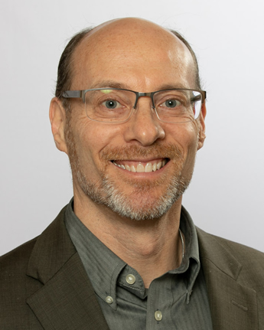Gary Scheiner, MS, CDCES

Owner & Clinical Director

Integrated Diabetes Services LLC

Gary Scheiner is owner and Clinical Director of Integrated Diabetes Services, a practice located just outside of Philadelphia specializing in intensive insulin therapy and advanced education for children and adults. Gary has been a Certified Diabetes Care & Education Specialist for 25 years and was named 2014 Diabetes Educator of the Year by the American Association of Diabetes Educators (AADE). He has written more than 100 articles for diabetes trade publications and seven books, including *“Think Like A Pancreas”* and “*Practical CGM*”. Gary served as lead author of ADCES’ best practice white paper on CGM and contributed to AACE’s consensus statement on CGM. He lectures nationally and internationally on the application of technology in diabetes care and has personally initiated CGM and analyzed data for more than 2000 patients worldwide.

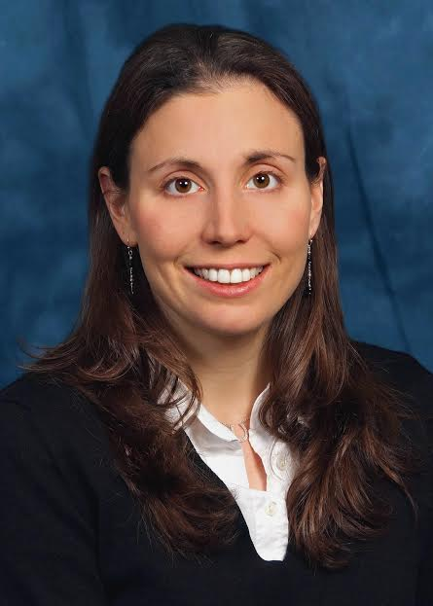 ***Disclosures:***

* Provention Bio- Clinical advisory board
* Eli Lilly- Diabetes Educator Advisory Board
* Medtronic- Connected Pen Advisory Board
* Xeris Pharmaceuticals-Medical Advisory Board
* Capillary Biomedical- Clinical Advisory Board
* Dexcom, Xeris Pharmaceuticals, Tandem Diabetes, and Insulet- Speakers Bureau
* Adocia, Mannkind- Consultant

Christie Schumacher, PharmD, BCPS, BCACP, BCCP, BC-ADM, CDCES, FCCP

Professor of Pharmacy Practice and Director of the PGY2 Ambulatory Care Residency Program

Midwestern University

Dr. Christie Schumacher is a Professor of Pharmacy Practice and Director of the PGY2 Ambulatory Care Residency Program at Midwestern University College of Pharmacy, Downers Grove Campus and a Clinical Pharmacist at Advocate Medical Group Southeast Center in Chicago, Illinois.  She currently works in a patient-centered medical home to provide comprehensive medication management for a variety of internal medicine disease states, including but not limited to, heart failure, diabetes, hypertension, hyperlipidemia, chronic obstructive pulmonary disease and asthma.  She currently serves as the Vice Chair on the Board of Pharmacy Specialties® Specialty Council on Ambulatory Care Pharmacy, is a past Chair of the American College of Clinical Pharmacy (ACCP) Endocrine and Metabolism Practice Research Network (PRN) and is the current Chair for the ACCP Ambulatory Care PRN. She is currently conducting research on clinical pharmacist workload in the ambulatory care setting and on clinical outcomes related to the management of patients with diabetes and heart failure.

***Disclosures:***

* Abbott FreeStyle Libre Continuous Glucose Monitor-Speakers Bureau

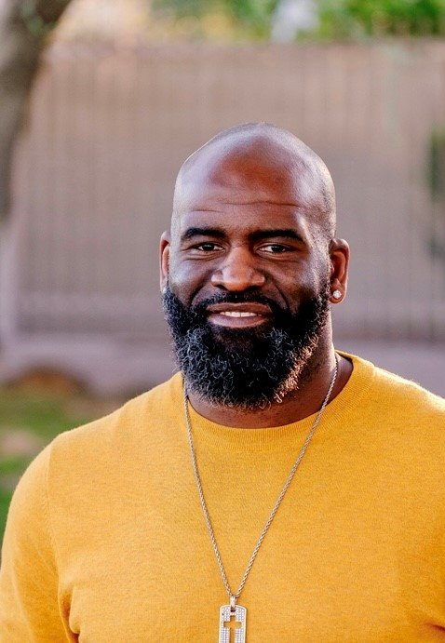

Kendall Simmons

Coach, T1D, NFL Alum

Kendall married has college sweetheart Celesta Henry from Smiths, Al. after being drafted by the Pittsburgh Steelers® as the 30th overall pick in 2002. They have four children Kensley, Laila and Olivia Pearl and Tyce. Following his first season, Simmons was selected as the team’s rookie of the year. Shortly before his second season began in 2003, Simmons was diagnosed with type 1 diabetes and was not sure if he would be able to continue his football career. With the help of team doctors and a strong support network, Simmons returned to the field that same year. He learned to manage my diabetes, regained his strength and flourished on the football field. Simmons spent the majority of his career with the Pittsburgh Steelers®, playing 7 NFL® seasons with the team and spanning 80 regular season and 7 post-season games. He also played his last season with the New England Patriots® and the Buffalo Bills.

He’s dedicated his time to diabetes care, raising awareness, properly managing blood glucose levels and to demonstrating that diabetes can be successfully integrated into your life as he traveled all over the US speaking to every age group. After retiring from the NFL®, Simmons is still very active in the diabetes community. Since 2019 he’s been about of the Auburn Football Staff as an Offensive Analyst and OL Assistant. He lives by this motto each and everyday. “This is the assigned moment for him to move into the center, while I slip off to the sidelines John 3:29-30”

***Disclosures:***

* Novo Nordisk-Employment

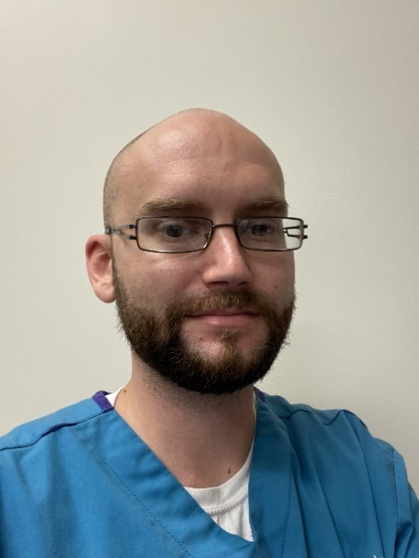

Justin Stang, CMA

Certified Medical Assistant

Northwestern Medical Group

Justin Stang is a Certified Medical Assistant for Northwestern Medicines Department of Endocrinology. Justin has experience in numerous specialties, including Family and Internal Medicine, Cardiology, Podiatry, Neurology, Orthopedics, Gastroenterology, and Pulmonology. Justin has a special interest in Endocrinology, process mapping, and navigating insurance coverages. Justin has worked on the integration of remote monitoring of CGM patients in clinics during the pandemic, as well as training and integrating CGM use in a primary care setting within Northwestern.

***Disclosures:*** No financial relationships to report

**Planners:**

Diana Isaacs, PharmD, BCPS, BCACP, BC-ADM, CDCES, FADCES, FCCP

***Disclosures:***

* Dexcom, Insulet, Medtronic, Abbott, Novo Nordisk, Bayer, Xeris Pharmaceuticals- Speakers Bureau
* Lilly, Sanofi, Tempramed, DiabetesWise, DiaTribe- Consultant

Davida Kruger, RN, MSN, NP, APRN, BC-ADM

***Disclosures:***

* Pendulum- Stock
* Novo, Lilly, Dexcom, Abbott, Xeris- Speakers Bureau
* Novo, Lilly, Sanofi, Abbott- Consultant

Lucia Novak, NP, BC-ADM

***Disclosures:***

* Abbott Diabetes Care, Novo Nordisk, Xeris; Former: AstraZeneca; Janssen-Speakers Bureau
* Novo Nordisk, Xeris, Sanofi, Proventio Bio- Consultant

Sean Oser, MD, MPH

***Disclosures:***

* Cecelia Health and Dexcom- Consultant

Tamara Oser, MD, MPH

***Disclosures:***

* Cecelia Health and Dexcom- Consultant

Dhiren Patel, PharmD, BC-ADM, CDCES

***Disclosures:***

* Abbott, Amarin, Astra Zeneca, Bayer, Boehringer Ingelheim, Dexcom, Lilly, Merck, Novo, Xeris, Zealand-Speaker’s Bureau
* Amarin, Bayer, Dexcom, Lilly, Insulet- Consultant

Anthony Pick, MD, CDCES

***Disclosures:***

* Abbott, Astra Zeneca, Novo Nordisk, Lilly- Speakers Bureau

Joanne Rinker MS, RDN, CDCES, LDN, FADCES

***Disclosures:*** No financial relationships to report

Jane Jeffrie Seley, DNP MPH MSN GNP BC-ADM CDCES FADCES

***Disclosures:*** No financial relationships to report

Hope Warshaw MMSc, RD, BC-ADM, CDCES, FADCES

***Disclosures:***No financial relationships to report