ADCES in Practice
Manuscript Submission Guide

Go to https://mc.manuscriptcentral.com/aip to create an account in Sage Track, our online manuscript submission and review tool. When prompted, enter keywords that indicate your areas of expertise and interest.
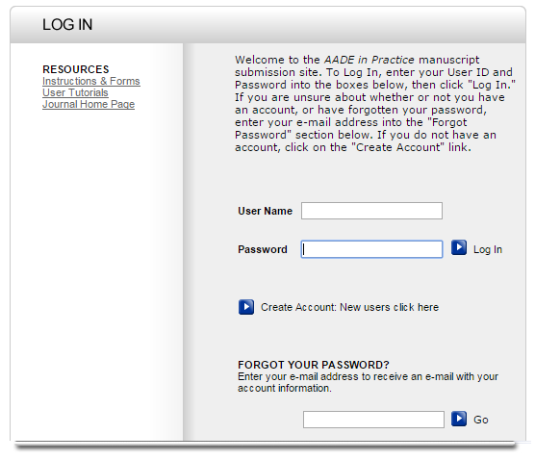
Your account will include an Author Center and a Reviewer Center. These will display on the Welcome page when you log in.
Click here to set up an account.
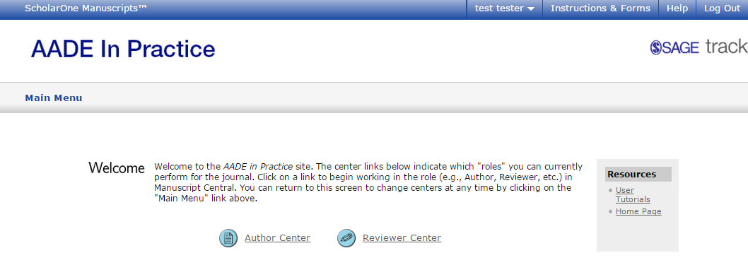
Author Center
Your Author Center is “control central” for managing and tracking your manuscript submissions.

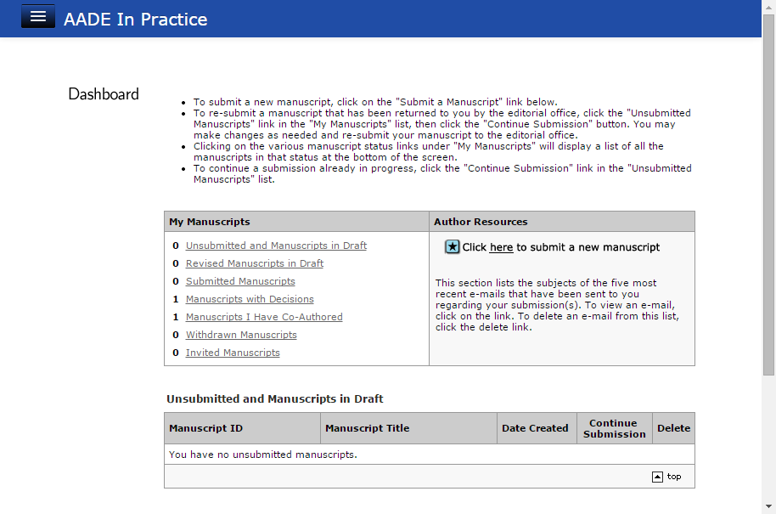
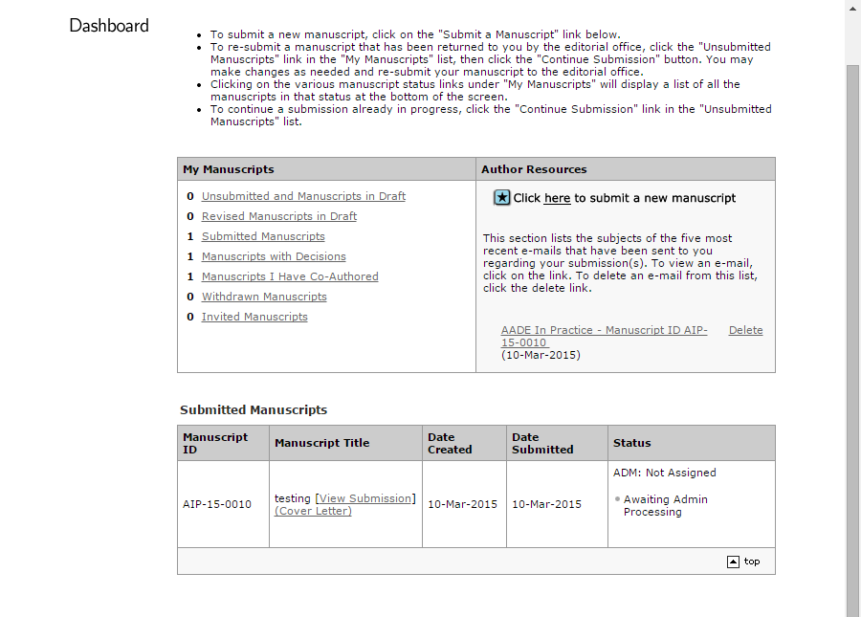
BEFORE SUBMITTING

Start your submission here.

AFTER SUBMITTING
Manuscripts in process appear in the queue. Recent emails display on the right.

When you select a manuscript in the queue, you can review the details, continue a submission, submit a revision, etc., from here.

7-step Submission Process
When you start a new submission, the system walks you through the steps to complete it. As you complete each step, you are led to the next on a new page. Items marked req must be completed for each step before you can continue.
Step 1
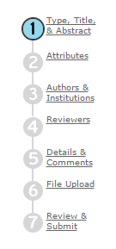
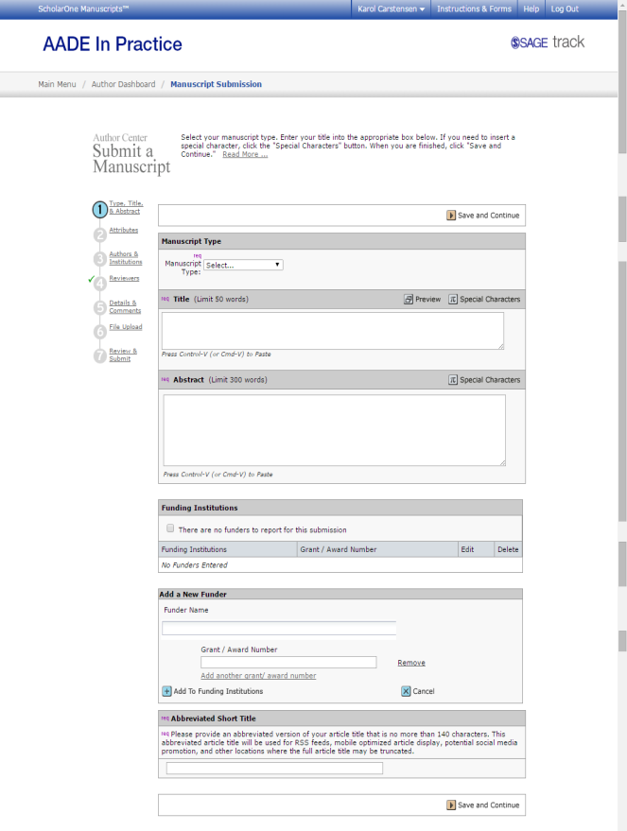

The system tracks your progress. Completed steps are checked off. The current step is highlighted. Navigation buttons allow you to move forward and back in the process. You can also select previous steps from the tracking bar.
Step 2

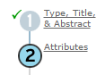
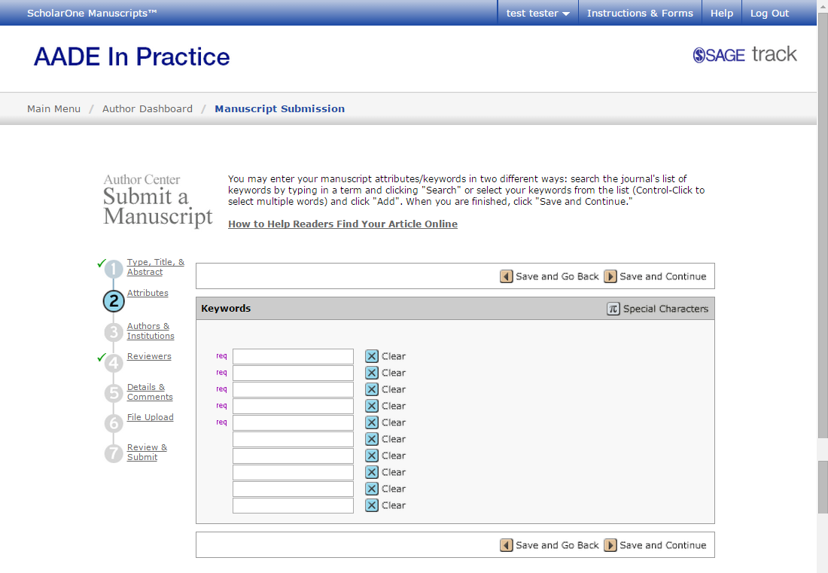
Every page has directions and help.

Tips and Tricks

Author Center
- To submit a revised version of a manuscript returned to you by the editorial office, select “Unsubmitted and Manuscripts in Draft” from the queue. Details and directions will appear at the bottom of the page.
- Recent emails from the editorial office appear in the box on the right of the page. You can open and respond to them from here or from your usual email inbox.

Step 1
- Abstracts are included in reviewer invitations. Describe the article in a way that helps reviewers determine their interest and qualifications for completing a review.
- Abstracts are not published as such in the Journal.

Step 2
- Keywords help the Journal identify qualified reviewers. Consider words that a colleague might use to define an area of interest or expertise that relates to your topic.
- Keywords also help your article to be located through online search. Choose them accordingly.
- The on-page directions indicate that you can search for keywords in the system. This feature is not active for AADE in Practice.

Step 3
- If you don’t have all the information to complete the co-author section, you can skip this. Just be sure to list your co-author, if any, on the title page. Please include at a minimum name, credentials, position/title and institution/affiliation.
- You must check the Co-Author Consent box, even if you do not enter co-author information on the page.

Step 4
- You may enter names and emails of people you would like to review your article. Designate these as “preferred.”
- The Journal is not obligated to use the reviewers you list.
- You may also list people you would prefer do not review your article. Designate these as “non-preferred.”

Step 5
- Be sure to count all the tables in your article, even if it’s just one you created in Word and included in the body of the text.
- Note that illustrations and tables should be uploaded in separate files.

Step 6
- At minimum you should be uploading two files, the article manuscript and a title page.
- Select the type of file for each upload. Your manuscript should be designated as the “main document.”
- It may take a minute for files to upload.
- A window will appear with details of the files you uploaded. Review the information to make sure you uploaded the correct files.
- The order of files shown is the order they will render in the document that reviewers get. You can change the number in front of each document to change the order. You must save the changes.

Step 7
- You must view the pdf proof of your article in order to complete your submission. Remember that the proof is what reviewers will receive.
- You can click on previous steps in the tracking bar if you wish to make changes.
- Click submit, and that’s it!

