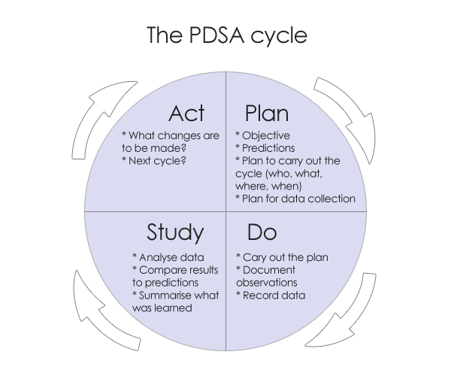
Three fundamental questions should be answered by the CQI project:
- What are we trying to accomplish?
- How will we know a change is an improvement?
- What changes can we make that will result in an improvement?
Your Organization__________________________________
Date__________
CONTINUOUS QUALITY IMPROVEMENT PROJECT
Plan (This is the section to complete for new plan each year)
What change are you testing (what problem are you trying to solve)?Explain the current situation and what you hope to change about it.

What do you predict will happen and why?

Who will be involved?

When will the change happen and how long will it take to implement? (timeline)

What resources will be needed?

What data need to be collected and when? (timeline)

Do (Complete this section as you are doing your test of change)
Carry out the change on a small scale. Collect data you identified in your plan. Explain here what you did and how you did it.

Document observations, including any problems and unexpected findings here.

Study (Complete this section once you have completed your test of change and have your data)
Analyze the data. Did the change result in the expected outcome?

Were there implementation lessons? Summarize what was learned.

Were there any unintended consequences, surprises, successes, failures?

Act(Complete this section AFTER you have evaluated your data and are deciding what to do with the results, i.e. next steps)
Based on what was learned from the test, select one of the following and elaborate:

Adapt – modify the changes and repeat PDSA cycle.

Adopt – consider expanding the changes in your organization.

Abandon – change your approach and repeat PDSA cycle.

